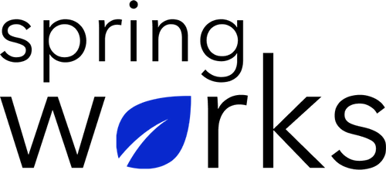
Free Template – 360 Surveys

Hasten Growth and development with targeted, impressive feedback.

360 Surveys include anonymous and confidential feedback about employees from their manager, peers, subordinates, vendors and customers . Copy this template to your Google Drive and customize it for your organization.

Communication (to be added as review instructions):

We can only make positive changes when we have the right information. All answers you give will be treated with the utmost sensitivity, and the information will not be used for any other purpose apart from planning and improvement. Please answer this quick survey by <HOUR OF THE DAY> on <DATE>.

Demographic Information:

The following information is requested so that meaningful analysis and comparisons of group results can be made. Please check the circle, corresponding to your answer.

Q: Your Gender:

- Male
- Female

Q: Your Department:

- Marketing
- Operations
- Tech
- Accounting
- HR

Q: Company Service:

- Under 1 Year
- 1-2 Year
- 3-5 Year
- 6-10 Year
- 10-15 Year
360 Survey

To answer clearly what you think or feel about each item, please follow these steps:

- Read each item fully before you start to mark your answer.
- Pick the one answer which most nearly says what you think or how you feel.
- While completing the questions, be sure to read the special instructions which are included.

Choose the answer which is most appropriate (Strongly Agree = 5 and Strongly Disagree =1)

Q: Does he/ she possess leadership quality in the work they do?

- Yes
- No

Q: He/ she solve problems effectively:

- 5
- 4
- 3
- 2
- 1
- N/A

Q: He/ She is motivated about the work related tasks, job and relationships within the team:

- 5
- 4
- 3
- 2
- 1
- N/A

Q: His/ Her work methods and approach to accomplish the job effectively, efficiently, and continuously are improving:

- 5
- 4
- 3
- 2
- 1
- N/A

Q: Have you experience any problem with him/ her interpersonally:

- Yes
- No

(If you agree, please describe the conflict).

Q: He/ She is trustworthy, ethical and honest:

- 5
- 4
- 3
- 2
- 1
- N/A

Q: He/ She can handle criticism:

- 5
- 4
- 3
- 2
- 1
- N/A

Q: On a scale of 1-5, how much do you rate him/ her on the basis of quality of work:

1 | 2 | 3 | 4 | 5

Q: Does he/ she motivate others to reach goals?:

- Yes
- No

Q: He/ She communicates well with supervisors, customers and colleagues:

- 5
- 4
- 3
- 2
- 1
- N/A

Q: Does he/ she represent as a responsible and honest team member?

- Yes
- No

Q: He/ She is able to work without any direction:

- 5
- 4
- 3
- 2
- 1
- N/A

Q: He/ She is good at working with team:

- 5
- 4
- 3
- 2
- 1
- N/A

Q: The three examples where he/ she can improve?

i.
ii.
iii.

Q: List three things that set him/ her apart from others within the team or organisation?

i.
ii.
iii.

Q: What else would you like to tell us about?

Many thanks for taking the time to fill in this survey.

